Assignment: One to Many

Partner #1: Curtis Nishihira

Partner #2: Jonathan Nguyen-Pham

Partner #3: Nhan Vo

**DDL:**

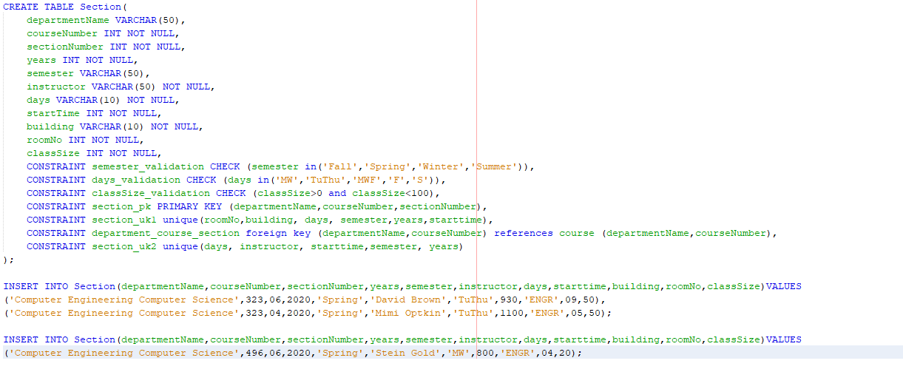

CREATE TABLE Section(

departmentName VARCHAR(50),

courseNumber INT NOT NULL,

sectionNumber INT NOT NULL,

years INT NOT NULL,

semester VARCHAR(50),

instructor VARCHAR(50) NOT NULL,

days VARCHAR(10) NOT NULL,

startTime INT NOT NULL,

building VARCHAR(10) NOT NULL,

roomNo INT NOT NULL,

classSize INT NOT NULL,

CONSTRAINT semester_validation CHECK (semester in('Fall','Spring','Winter','Summer')),

CONSTRAINT days_validation CHECK (days in('MW','TuThu','MWF','F','S')),

CONSTRAINT classSize_validation CHECK (classSize>0 and classSize<100),

CONSTRAINT section_pk PRIMARY KEY (departmentName,courseNumber,sectionNumber),

CONSTRAINT section_uk1 unique(roomNo,building, days, semester,years,starttime),

CONSTRAINT department_course_section foreign key (departmentName,courseNumber) references course (departmentName,courseNumber),

CONSTRAINT section_uk2 unique(days, instructor, starttime,semester, years)

);

* Section pk because the most unique identifier for classes is always ie CECS232 sec05
* Candidate keys uk1 you can't have the same section at the same place at the same time
* Candidate keys uk2 you can't have the the same instructor teaching multiple sections at the same time

**Report rows in Section table:**

|  |  |  |  |  |  |  |  |  |  |  |
| --- | --- | --- | --- | --- | --- | --- | --- | --- | --- | --- |
| DEPARTMENTNAME | COURSENUMBER | SECTIONNUMBER | YEARS | SEMESTER | INSTRUCTOR | DAYS | STARTTIME | BUILDING | ROOMNO | CLASSSIZE |
| Computer Engineering Computer Science | 323 | 6 | 2020 | Spring | David Brown | TuThu | 930 | ENGR | 9 | 50 |
| Computer Engineering Computer Science | 323 | 4 | 2020 | Spring | Mimi Optkin | TuThu | 1100 | ENGR | 5 | 50 |
| Computer Engineering Computer Science | 496 | 6 | 2020 | Spring | Stein Gold | MW | 800 | ENGR | 4 | 20 |

**The console text that you received when you tried to insert a Section for a non-existent course:**



* CECS 496 does not exist in the course. Hence, it will cause error when we trying to add a section

**Improved join select statement:**

Text:

select dept.name, dept.chair, c.courseName, s.sectionNumber,s.instructor,s.semester,s.days,s.startTime, c.courseNumber, c.units

from department dept inner join course c on dept."NAME" = c.DEPARTMENTNAME inner join Section s on s.courseNumber=c.courseNumber

order by dept."NAME", c.courseNumber;

Output:

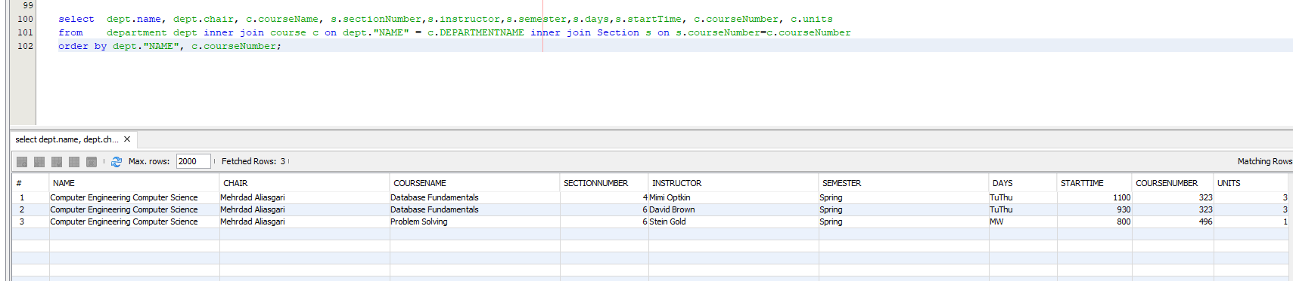

Report:

|  |  |  |  |  |  |  |  |  |  |
| --- | --- | --- | --- | --- | --- | --- | --- | --- | --- |
| NAME | CHAIR | COURSENAME | SECTIONNUMBER | INSTRUCTOR | SEMESTER | DAYS | STARTTIME | COURSENUMBER | UNITS |
| Computer Engineering Computer Science | Mehrdad Aliasgari | Database Fundamentals | 4 | Mimi Optkin | Spring | TuThu | 1100 | 323 | 3 |
| Computer Engineering Computer Science | Mehrdad Aliasgari | Database Fundamentals | 6 | David Brown | Spring | TuThu | 930 | 323 | 3 |
| Computer Engineering Computer Science | Mehrdad Aliasgari | Problem Solving | 6 | Stein Gold | Spring | MW | 800 | 496 | 1 |